**Kathmandu University**

**Department of Computer Science and Engineering Dhulikhel, Kavre**



**Mini Report**

**on**

**“Lab 2”**

**[Course Code: COMP 342]**

**(For partial fulfillment of III Year/ I Semester in Computer Science)**

**Submitted By**

**Nisham Ghimire (22)**

**Submitted To**

**Mr. Dhiraj Shrestha**

**Department of Computer Science and Engineering**

**Submission Date**

**27th October, 2023**

1. **Implement Digital Differential Analyzer Line drawing algorithm.**

**Ans:**

1. ***Start Algorithm***
2. ***Declare variables: Declare x1, y1, x2, y2, dx, dy, steps, Xinc, Yinc, X, Y, and vertices.***
3. ***Input coordinates: Assign the values of x1, y1, x2, and y2.***
4. ***Calculate dx and dy: Calculate dx as x2 - x1 and dy as y2 - y1.***
5. ***Calculate steps: Calculate steps as the maximum of abs(dx) and abs(dy).***
6. ***Calculate Xinc and Yinc: Calculate Xinc as dx / steps and Yinc as dy / steps.***
7. ***Initialize X and Y: Assign X to x1 and Y to y1.***
8. ***Calculate vertices: Repeat steps times:***

***a. Append (X, Y) to vertices.***

***b. Add Xinc to X.***

***c. Add Yinc to Y.***

1. ***Append end coordinate: Append (x2, y2) to vertices.***
2. ***Draw line: For each vertex in vertices, call glVertex2f with the x and y coordinates of the vertex.***
3. ***End Algorithm***

from typing import Tuple

import pygame as pg

from pygame import display, event

from pygame.locals import *

from OpenGL.GL import *

from OpenGL.GLU import *

def DDA(start_coordinate: Tuple[int, int], end_coordinate: Tuple[int, int]) -> list[Tuple[float, float]]:

    x1, y1 = start_coordinate

    x2, y2 = end_coordinate

    dx = x2 - x1

    dy = y2 - y1

    steps = max(abs(dx), abs(dy))

    Xinc = dx / steps

    Yinc = dy / steps

    X = x1

    Y = y1

    vertices: list[Tuple[float, float]] = []

    for i in range(steps):

        vertices.append((X, Y))

        X = X + Xinc

        Y = Y + Yinc

    return vertices

def drawDDA():

    vertices = DDA((100, 250), (350, 450))

    glClear(GL_COLOR_BUFFER_BIT)

    glBegin(GL_LINE_STRIP)

    glColor3f(1.0, 1.0, 1.0)

    for v in vertices:

        x, y = v

        glVertex2f(x, y)

    glEnd()

    glFlush()

def main():

    pg.init()

    display.set_mode((500, 500), DOUBLEBUF | OPENGL | GL_RGB)

    display.set_caption("DDA - Nisham Ghimire")

    gluOrtho2D(0, 500, 0, 500)

    while True:

        for ev in event.get():

            if ev.type == pg.QUIT:

                pg.quit()

                quit()

        drawDDA()

        display.flip()

main()

**Output:**

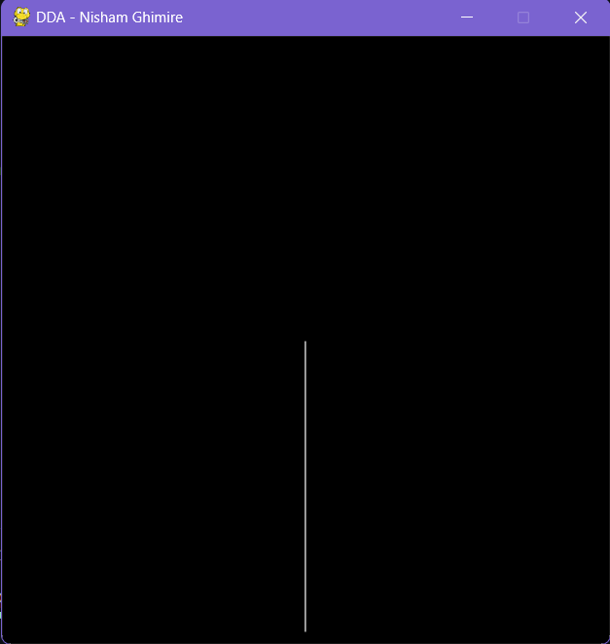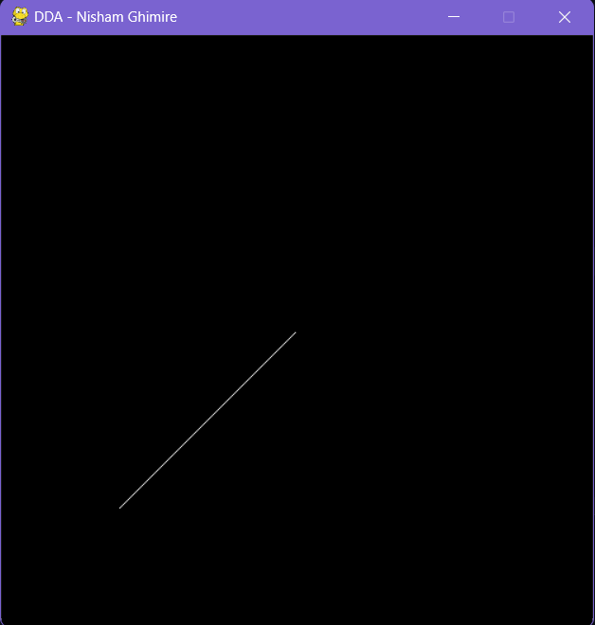

**2. Implement Bresenham Line Drawing algorithm for both slopes(|m|<1 and |m|>=1).**

**Ans:**

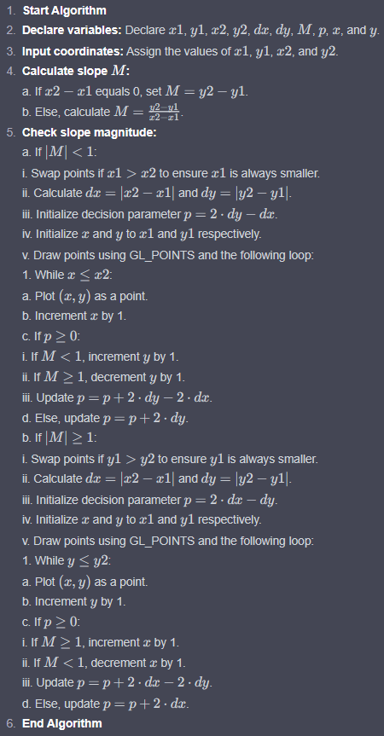

import pygame

from pygame import display,event

from OpenGL.GL import *

from OpenGL.GLU import *

import math

def Draw():

    x1, y1, x2, y2 = 100, 200 , 300, 400

    glClear(GL_COLOR_BUFFER_BIT)

    if (x2-x1) == 0:

        M = (y2-y1)

    else:

        M = (y2-y1)/(x2-x1)

    if abs(M) < 1:

        if x1 > x2:

            t = x1

            x1 = x2

            x2 = t

            t = y1

            y1 = y2

            y2 = t

        dx = abs(x2-x1)

        dy = abs(y2-y1)

        p = 2*dy-dx

        x = x1

        y = y1

        glBegin(GL_POINTS)

        while x <= x2:

            glVertex2f(x, y)

            x = x+1

            if p >= 0:

                if M < 1:

                    y = y+1

                else:

                    y = y-1

                p = p+2*dy-2*dx

            else:

                y = y

                p = p+2*dy

        glEnd()

    if abs(M) >= 1:

        if y1 > y2:

            t = x1

            x1 = x2

            x2 = t

            t = y1

            y1 = y2

            y2 = t

        dx = abs(x2-x1)

        dy = abs(y2-y1)

        p = 2*dx-dy

        x = x1

        y = y1

        glBegin(GL_POINTS)

        while y <= y2:

            glVertex2f(x, y)

            y = y+1

            if p >= 0:

                if M >= 1:

                    x = x+1

                else:

                    x = x-1

                p = p+2*dx-2*dy

            else:

                x = x

                p = p+2*dx

        glEnd()

    glFlush()

def main():

    pygame.init()

    display.set_mode((500, 500), pygame.DOUBLEBUF | pygame.OPENGL )

    display.set_caption("BLA - Nisham Ghimire")

    gluOrtho2D(0, 500, 0, 500)

    while True:

        for event in pygame.event.get():

            if event.type == pygame.QUIT:

                pygame.quit()

                quit()

        Draw()

        pygame.display.flip()

if __name__ == '__main__':

    main()

**Output:**

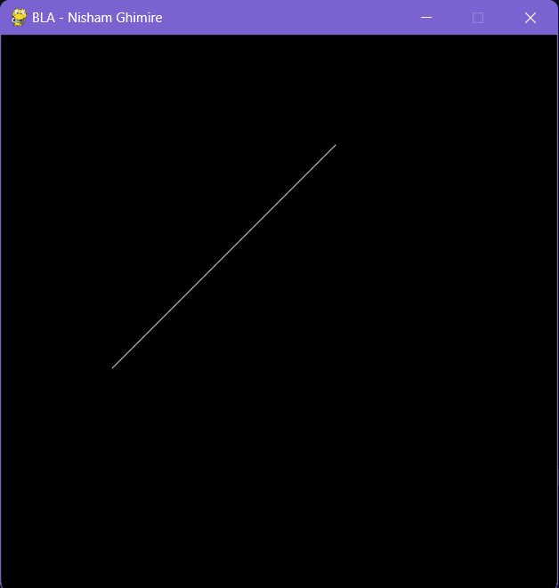

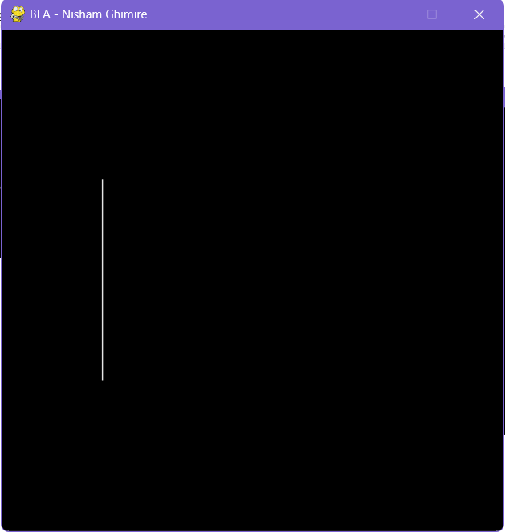

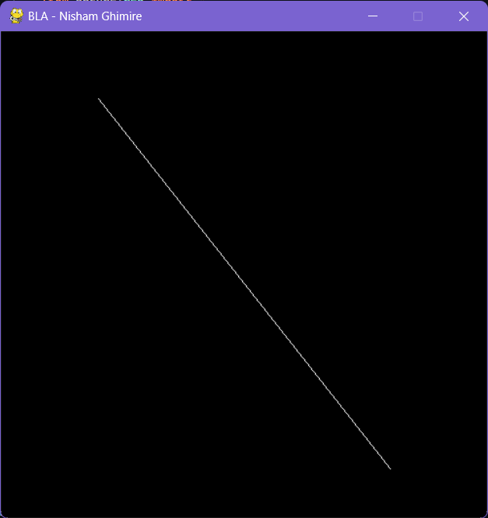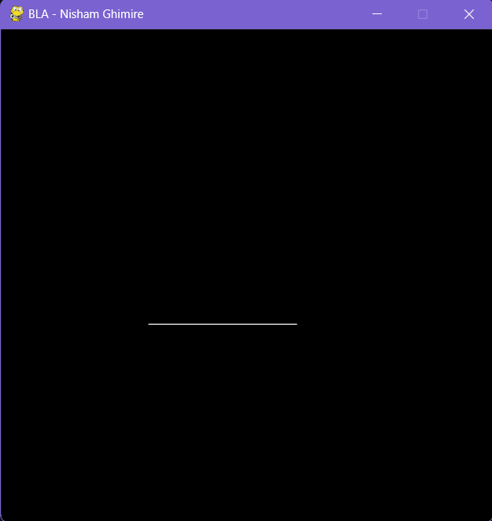

**Conclusion:**

After completing this lab work, I have learned how to draw lines using DDA and Bresenham algorithms in Python. I utilized Python, OpenGL APIs, and pygame for window creation. This practical experience enhanced my understanding of computer graphics and equipped me with valuable programming skills.